**Experiment 5**

**(Server-Side Scripting)**

**Name: Nishant Golakiya**

**Sap: 60009220150**

**Batch: D2-2**

**Aim**: Implement Server side scripting using Nodejs

**Lab Assignments to complete in this session**

1. **Installation and Configuration of Node.js server**
2. **Export functions and variables in module**
3. **Program based on inbuilt functions in Node.js e.g. os, path, fs**
4. **Create imports the "http" module and uses it to create a server**
5. **Create a text file named input.txt with the following content**

**Theory**:

Node.js is a platform built on Chrome's JavaScript runtime for easily building fast and scalable network applications. Node.js uses an event-driven, non-blocking I/O model that makes it lightweight and efficient, perfect for data-intensive real-time applications that run across distributed devices.

Node.js is an open source, cross-platform runtime environment for developing server-side and networking applications. Node.js applications are written in JavaScript, and can be run within the Node.js runtime on OS X, Microsoft Windows, and Linux.

Node.js also provides a rich library of various JavaScript modules which simplifies the development of web applications using Node.js to a great extent.

Node.js = Runtime Environment + JavaScript Library

**Where to Use Node.js?**

Following are the areas where Node.js is proving itself as a perfect technology partner.

* I/O bound Applications
* Data Streaming Applications
* Data Intensive Real-time Applications (DIRT)
* JSON APIs based Applications
* Single Page Applications

**Where Not to Use Node.js?**

* It is not advisable to use Node.js for CPU intensive applications.

[**Installing Node**](https://developer.mozilla.org/en-US/docs/Learn/Server-side/Express_Nodejs/development_environment#installing_node)

In order to use *Express* you will first have to install *Nodejs* and the [Node Package Manager (NPM)](https://docs.npmjs.com/)

1. Install NodeJs:
   1. Go to <https://nodejs.org/en/>
   2. Select the button to download the LTS build that is "Recommended for most users".Install Node by double-clicking on the downloaded file and following the installation prompts.
2. [Testing Nodejs and NPM installation](https://developer.mozilla.org/en-US/docs/Learn/Server-side/Express_Nodejs/development_environment#testing_your_nodejs_and_npm_installation)

> node -v

v12.18.4

1. Creating function and displaying message on console

function intro(msg)

{

console.log(msg)

}

intro("Good Morning")

1. Export functions and variables in module

This is **intro.js** file

function intro(msg)

{

console.log(msg)

}

module.exports.intro = intro

This is **main.js** file

var p=require(‘./intro.js’)

p.intro(“Module called”)

Run Program

>node main.js

Module called

# **Node.js Built-in Modules**

Node.js has a set of built-in modules which you can use without any further installation.

Here is a list of the built-in modules of Node.js version 6.10.3:

|  |  |
| --- | --- |
| **Module** | **Description** |
| [buffer](https://www.w3schools.com/nodejs/ref_buffer.asp) | To handle binary data |
| [events](https://www.w3schools.com/nodejs/ref_events.asp) | To handle events |
| [fs](https://www.w3schools.com/nodejs/ref_fs.asp) | To handle the file system |
| [http](https://www.w3schools.com/nodejs/ref_http.asp) | To make Node.js act as an HTTP server |
| [https](https://www.w3schools.com/nodejs/ref_https.asp) | To make Node.js act as an HTTPS server. |
| [net](https://www.w3schools.com/nodejs/ref_net.asp) | To create servers and clients |
| [os](https://www.w3schools.com/nodejs/ref_os.asp) | Provides information about the operation system |
| [path](https://www.w3schools.com/nodejs/ref_path.asp) | To handle file paths |

## File System Methods

|  |  |
| --- | --- |
| **Method** | **Description** |
| access() | Checks if a user has access to this file or directory |
| accessSync() | Same as access(), but synchronous instead of asynchronous |
| appendFile() | Appends data to a file |
| chmod() | Changes the mode of a file |
| chown() | Changes the owner of a file |
| close() | Closes a file |
| open() | Opens a file |
| read() | Reads the content of a file |
| readdir() | Reads the content of a directory |
| readFile() | Reads the content of a file |
| realpath() | Returns the absolute pathname |
| rename() | Renames a file |
| rmdir() | Removes a directory |
| stat() | Returns the status of a file |
| truncate() | Truncates a file |
| unlink() | Removes a link |
| write() | Writes buffer to a file |
| write() | Writes data to a file |

The File System module provides a way of working with the computer's file system.

The syntax for including the File System module in your application:

var fs = require('fs');

1. **Open a file, and output the content:**

var fs = require('fs');  
 fs.readFile('demofile.txt', 'utf8', function(err, data) {  
  if (err) throw err;  
  console.log(data);  
});

Node development environment up and running on computer that can be used for creating Express web applications. Also seen how NPM can be used to import Express into an application.

**Lab Assignments to complete in this session**

1. **Installation and Configuration of Node.js server**
2. **Export functions and variables in module**

**Code:**

const myModule = require('./myModule');

console.log(myModule.myVariable);

myModule.myFunction();

const myVariable = 'Hello from myModule!';

const myFunction = () => {

    console.log('Function in myModule');

};

module.exports = {

    myVariable,

    myFunction

};

**Output:**

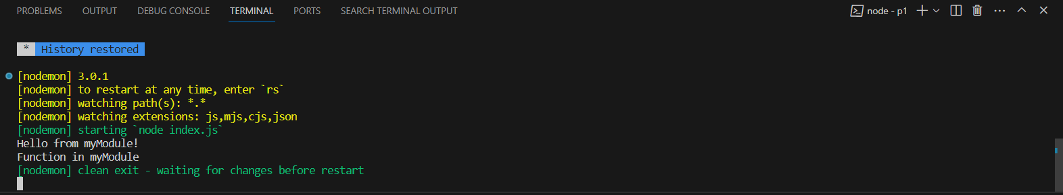

1. **Program based on inbuilt functions in Node.js e.g. os, path, fs**

**Code:**

const fs = require('fs');

fs.readFile('input.txt', 'utf8', (err, data) => {

    if (err) {

        console.error(err);

        return;

    }

    console.log(data);

});

**Output:**

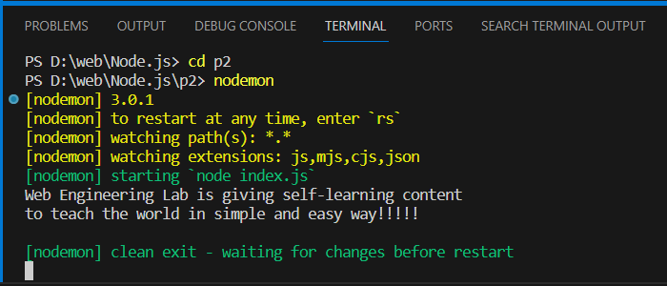

1. **Create imports the "http" module and uses it to create a server**

**Code:**

const http = require('http');

const server = http.createServer((req, res) => {

    res.writeHead(200, { 'Content-Type': 'text/plain' });

    res.end('Hello, this is a basic HTTP server!');

});

server.listen(3000, '127.0.0.1', () => {

    console.log('Server is running at http://127.0.0.1:3000/');

});

**Output:**

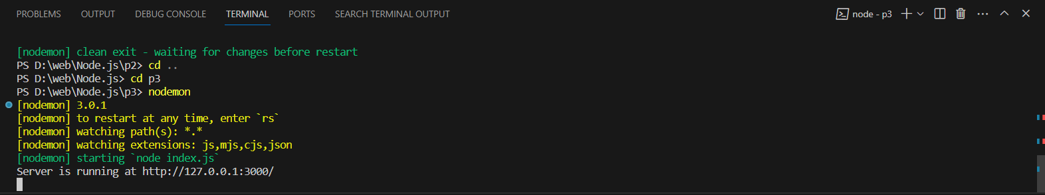

1. **Create a text file named input.txt with the following content**

Web Engineering Lab is giving self-learning content

to teach the world in simple and easy way!!!!!

**Create a js file to read this .txt file**